Hospital Management Package (Oracle PL/SQL)
👥 Group Members

- Database Tables Creation
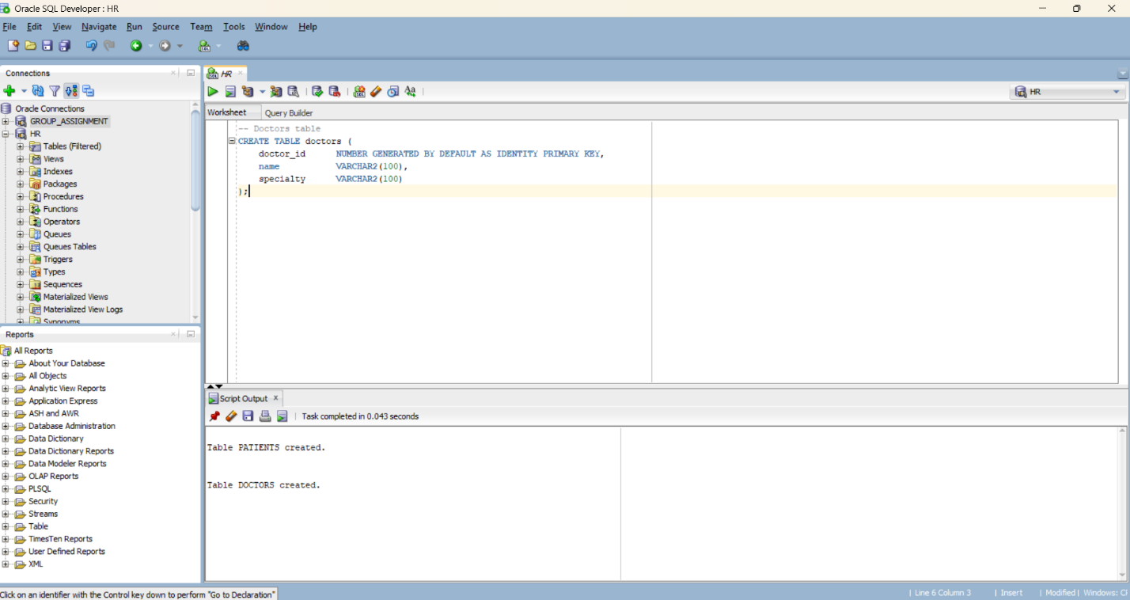
Fig 1:doctors table
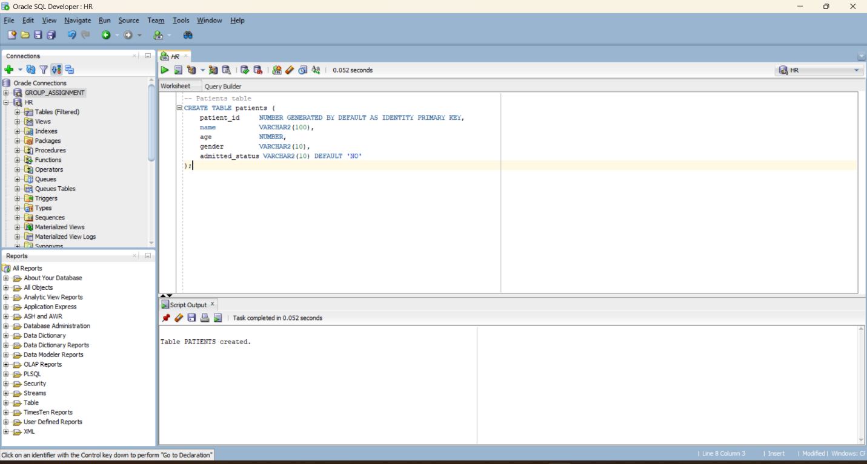
Fig2:patients table
- Package Specification (hospital_pkg)
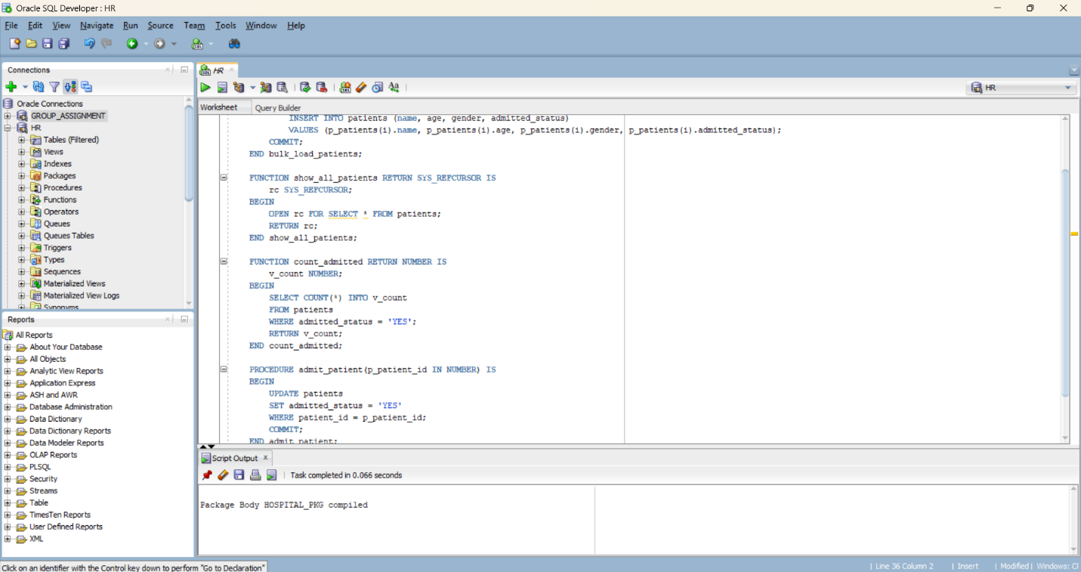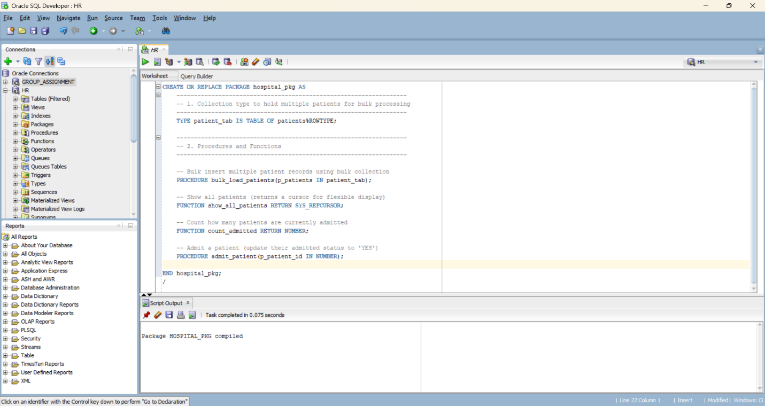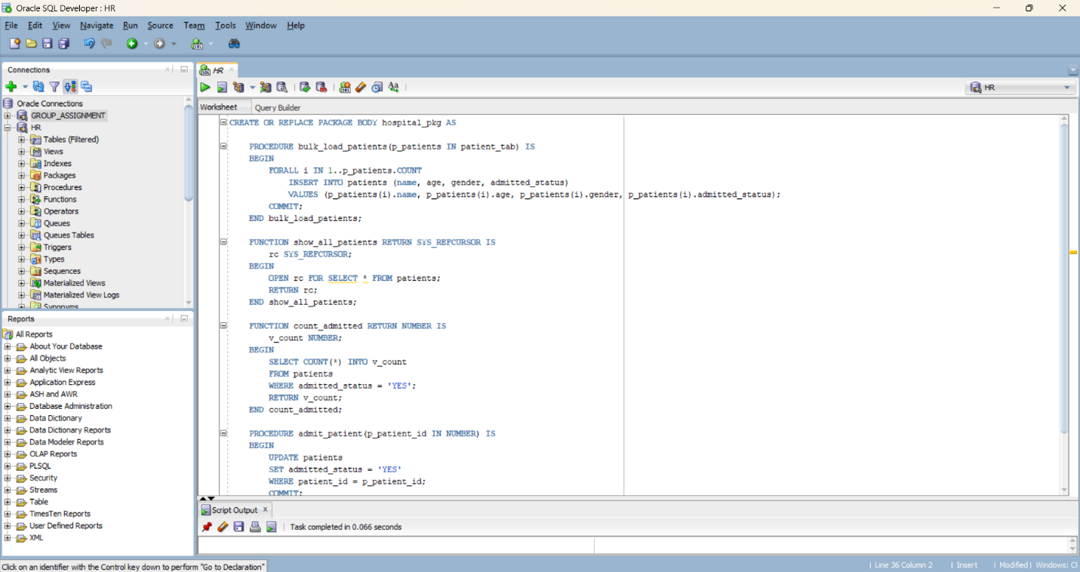
- Package Body Implementation
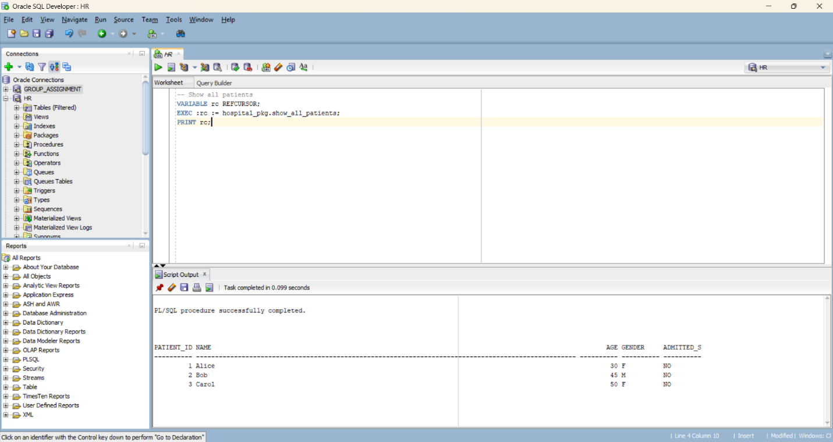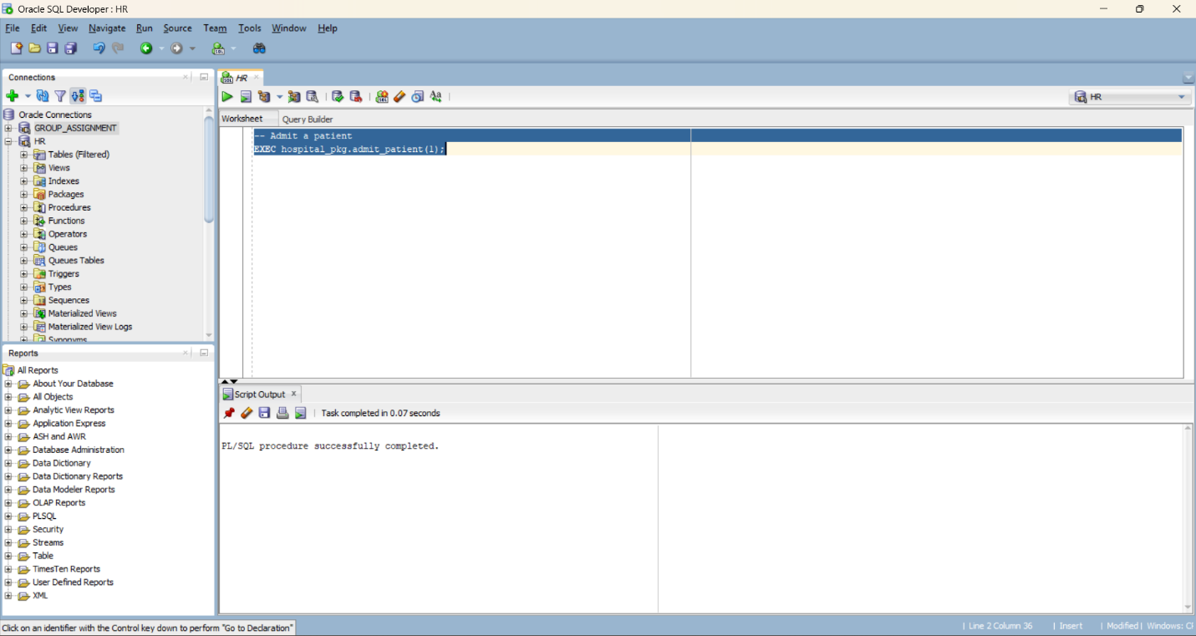

Project Overview
This project implements a modular PL/SQL package designed for a hospital setting. It simplifies how patient and doctor information is processed by using bulk operations, structured types, and cursor-based data retrieval. The goal is to provide a clean, efficient backend for hospital data management.

Database Structure
Patients Table
Manages records of patients with fields such as:
- patient_id — auto-generated primary key
- name — full name
- age — integer value representing age
- gender — male/female
- admitted_status — whether the patient is admitted
Doctors Table
Stores information related to doctors:
- doctor_id — auto-generated primary key
- name — doctor’s name
- specialty — medical specialization

Package Functionality (hospital_pkg)
The package provides:
- Custom collection type: patient_tab for handling multiple patients at once
- Bulk loading procedure using FORALL
- Data retrieval cursor returning all patient records
- Function for counting admitted patients
- Procedure for updating a patient’s admission status

Testing & Usage Examples
1. Bulk Insert Patients
DECLARE
l_patients hospital_pkg.patient_tab := hospital_pkg.patient_tab();
BEGIN
l_patients.EXTEND(2);
l_patients(1).name := 'Alice';
l_patients(1).age := 30;
l_patients(1).gender := 'F';
l_patients(1).admitted_status := 'NO';

l_patients(2).name := 'Bob';
l_patients(2).age := 45;
l_patients(2).gender := 'M';
l_patients(2).admitted_status := 'NO';

hospital_pkg.bulk_load_patients(l_patients);
END;
/
2. Retrieve All Patients
Uses a REF CURSOR to fetch all data.
3. Admit a Patient
EXEC hospital_pkg.admit_patient(1);
4. Count Currently Admitted Patients
SELECT hospital_pkg.count_admitted FROM dual;

Conclusion
This PL/SQL package successfully demonstrates bulk operations, cursor-based retrieval, and record updates — all essential components in building a reliable hospital information management backend. The structure is clean, maintainable, and meets the project requirements.

